**CHAROTAR UNIVERSITY OF SCIENCE & TECHNOLOGY**

**DEVANG PATEL INSTITUE OF ADVANCE TECHNOLOGY AND RESEARCH**

**NAME: Parth N Patel**

**ID: 19DCS098**

**SUBJECT: DBMS (Mini Project)**

**SUBJECT CODE: CE246**

**SEM: 4**

**PROJECT TITLE: BUS RESERVATION SYSTEM**

**DATA DICTIONARY:**

**TABLE NAME:** BUS_INFO

|  |  |  |  |
| --- | --- | --- | --- |
| **COLUMN NAME** | **DATA TYPE** | **LENGTH** | **DESCRIPTION** |
| BUS_ID | Number | 3 | For uniquely identify all buses |
| BUS_NAME | Varchar2 | 10 | Name of bus |
| DRIVER_ID | Number | 3 | Id of driver driving the bus |
| TOTAL_SEATS | Number | 2 | Seats of bus |
|  |  |  |  |
| RESERVED_SEATS | Number | 2 | Reserved seats in bus |

**TABLE NAME:** DRIVER

|  |  |  |  |
| --- | --- | --- | --- |
| **COLUMN NAME** | **DATA TYPE** | **LENGTH** | **DESCRPITION** |
| DRIVER_ID | Number | 2 | ID of the driver |
| DRIVER_NAME | Varchar2 | 20 | Name of driver |

**TABLE NAME:** CUSTOMER

|  |  |  |  |
| --- | --- | --- | --- |
| **COLUMN NAME** | **DATA TYPE** | **LENGTH** | **DESCRIPTION** |
| CUSTOMER_ID | Number | 3 | ID of customer |
| CUSTOMER_NAME | Varchar2 | 20 | Name of customer |
| PHONE | Number | 10 | Phone number of customers |

**TABLE NAME**: RESERVATION_STATUS

|  |  |  |  |
| --- | --- | --- | --- |
| **COLUMN NAME** | **DATA TYPE** | **LENGTH** | **DESCRIPTION** |
| SEAT_NO | Number | 4 | Seat number in bus |
| CUSTOMER_ID | Number | 3 | ID of customer travelling |
| BUS_ID | Number | 3 | ID of BUS having seat number |
| STATUS | Char | 3 | We let know whether seat reserved or not |

**E-R DIAGRAM:**

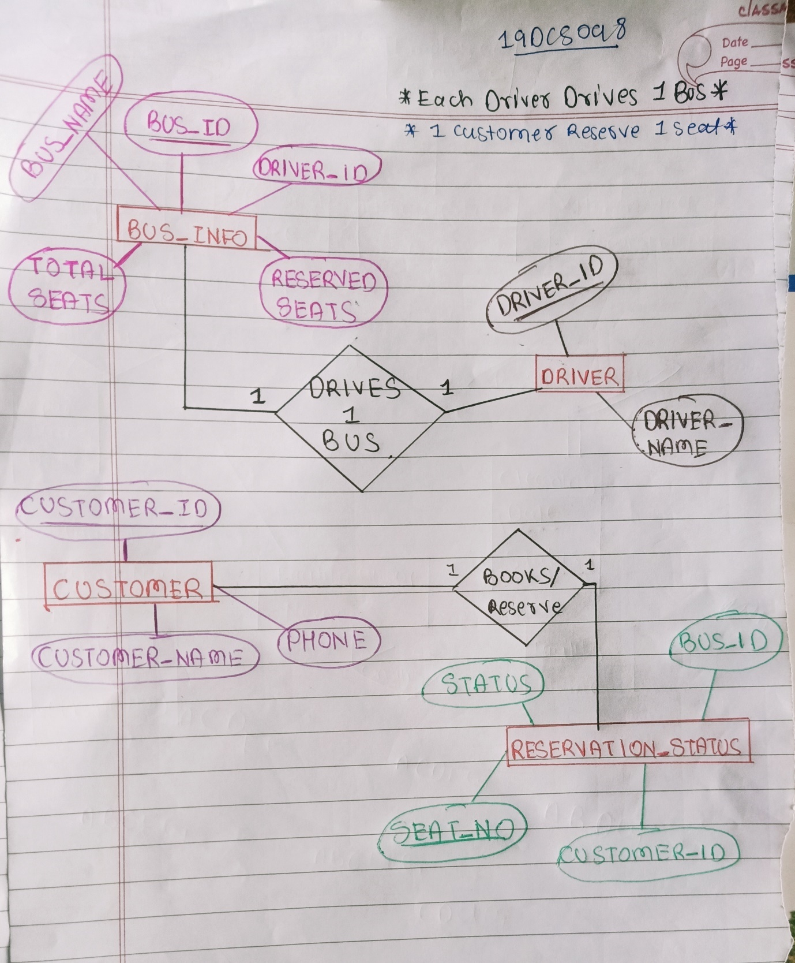

**PROGRAM CODE:**

/* CODE FOR CREATING TABLES */

CREATE TABLE bus_info ( bus_id NUMBER(3), bus_name VARCHAR2(10), driver_id NUMBER(3), total_seats NUMBER(2), reserved_seats NUMBER(2));

CREATE TABLE driver (driver_id NUMBER(2), driver_name VARCHAR2(20));

CREATE TABLE customer (customer_id NUMBER(3), customer_name VARCHAR2(20), phone NUMBER(10));

CREATE TABLE reservation_status (seat_no NUMBER(4), customer_id NUMBER(3), bus_id NUMBER(3), status CHAR(3));

/* CODE FOR ASSIGNNING THE PRIMARY KEY TO TABLES */

ALTER TABLE bus_info ADD CONSTRAINT pk_bus_id PRIMARY KEY(bus_id);

ALTER TABLE customer ADD CONSTRAINT pk_customer_id PRIMARY KEY(customer_id);

ALTER TABLE driver ADD CONSTRAINT pk_driver_id PRIMARY KEY(driver_id);

ALTER TABLE reservation_status ADD CONSTRAINT pk_seat_no PRIMARY KEY(seat_no);

/*ASSIGNNING THE FOREIGN KEY */

ALTER TABLE reservation_status

ADD CONSTRAINTS fk_customer_id FOREIGN KEY(customer_id) REFERENCES customer;

ALTER TABLE reservation_status

ADD CONSTRAINTS fk_bus_id FOREIGN KEY(bus_id) REFERENCES bus_info;

ALTER TABLE bus_info

ADD CONSTRAINTS fk_driver_id FOREIGN KEY(driver_id) REFERENCES driver;

/* CODE FOR INSERTING THE DATA IN DRIVER TABLE */

CREATE OR REPLACE PROCEDURE UPDATE_DRIVER(id NUMBER, name VARCHAR2)

IS

BEGIN

IF(id>0) THEN

INSERT INTO driver(driver_id,driver_name) VALUES (id,name);

DBMS_OUTPUT.PUT_LINE('DRIVER INFO UPDATED');

ELSE

DBMS_OUTPUT.PUT_LINE('ERROR ENCOUNTERED');

END IF;

END

/* CODE FOR INSERTING THE BUS DATA */

CREATE OR REPLACE PROCEDURE BUS(id NUMBER, busname VARCHAR2,seat NUMBER)

IS BEGIN

IF(id>0) THEN

INSERT INTO bus_info(bus_id,bus_name,total_seats,reserved_seats) VALUES (id,busname,seat,0);

DBMS_OUTPUT.PUT_LINE('BUS INFO UPDATED');

ELSE

DBMS_OUTPUT.PUT_LINE('ERROR ENCOUNTERED');

END IF;

END;

/* CODE FOR INSERTING THE CUSTOMER DATA */

CREATE OR REPLACE PROCEDURE CUSTOMER_INFO(id NUMBER,name VARCHAR2,ph NUMBER)

IS BEGIN

IF(id>0) THEN

INSERT INTO customer(customer_id,customer_name,phone) VALUES (id,name,ph);

DBMS_OUTPUT.PUT_LINE('CUSTOMER INFORMATION UPDATED');

ELSE

DBMS_OUTPUT.PUT_LINE('ERROR ENCOUNTERED');

END IF;

END;

/*CODE FOR INSERTING CUSTOMER DETAILS IN RESERVATION TABLE*/

CREATE OR REPLACE PROCEDURE RESERVATION_INFO(id NUMBER,b_id NUMBER)

IS BEGIN

IF(id>0) THEN

INSERT INTO reservation_status(seat_no,bus_id,status) VALUES (id,b_id,'NO');

DBMS_OUTPUT.PUT_LINE('SEAT INFORMATION UPDATED');

ELSE

DBMS_OUTPUT.PUT_LINE('ERROR ENCOUNTERED');

END IF;

END;

/* CODE FOR ASSIGNNING THE DRIVER TO HIS/HER BUS */

CREATE OR REPLACE PROCEDURE ASSIGN_DRIVER(id NUMBER,d_id NUMBER)

IS BEGIN

IF(id>0) THEN

UPDATE bus_info SET driver_id=d_id WHERE bus_id=id;

DBMS_OUTPUT.PUT_LINE('DRIVER ASSIGNED TO BUS');

ELSE

DBMS_OUTPUT.PUT_LINE('ERROR ENCOUNTERED');

END IF;

END;

/*CODE FOR CONFIRMING THE RESERVATION */

CREATE OR REPLACE PROCEDURE CONFIRM_RESERVATION(id NUMBER,cust_id NUMBER,b_id NUMBER)

IS BEGIN

IF(id>0) THEN

UPDATE reservation_status SET customer_id=cust_id,bus_id=b_id,status='YES' WHERE seat_no=id;

UPDATE bus_info SET reserved_seats=reserved_seats+1 WHERE bus_id=b_id;

DBMS_OUTPUT.PUT_LINE('RESERVATION CONFIRMED');

ELSE

DBMS_OUTPUT.PUT_LINE('ERROR ENCOUNTERED');

END IF;

END;

/*CODE FOR CANCELLING THE RESERVATION */CREATE OR REPLACE PROCEDURE DELETE_RESERVATION(id NUMBER,b_id NUMBER)

IS BEGIN

IF(id>0) THEN

UPDATE reservation_status SET customer_id=NULL,bus_id=NULL,status='NO' WHERE seat_no=id;

UPDATE bus_info SET reserved_seats=reserved_seats-1 WHERE bus_id=b_id;

DBMS_OUTPUT.PUT_LINE('RESERVATION CANCELLED');

ELSE

DBMS_OUTPUT.PUT_LINE('ERROR ENCOUNTERED');

END IF;

END;

/* CREATING VIEW FOR CUSTOMER TO SEE THE RESERVATION INFORMATION*/

CREATE VIEW customer_view AS

SELECT c.customer_id,c.customer_name,c.phone,r.seat_no,r.bus_id,r.status

FROM customer c INNER JOIN reservation_status r ON c.customer_id=r.customer_id;

/* CREATING VIEW FOR DRIVER AND BUS ASSIGNED TO THEM */

CREATE VIEW driver_view AS

SELECT d.driver_id,d.driver_name,b.bus_id,b.bus_name

FROM driver D INNER JOIN bus_info b ON d.driver_id=b.driver_id;

/* CREATING VIEW FOR OWNER TO SEE WHICH DRIVER IS ASSIGNNED TO WHICH BUS */

CREATE VIEW TRANSPORTER_VIEW_BUS AS

SELECT d.driver_id,d.driver_name,b.bus_id,b.bus_name,b.total_seats,b.reserved_seats

FROM driver d INNER JOIN bus_info b ON d.driver_id=b.driver_id;

**IMPLEMENTATION SCREEN SHOTS:**

* **DETAILS OF BUS_INFO**:

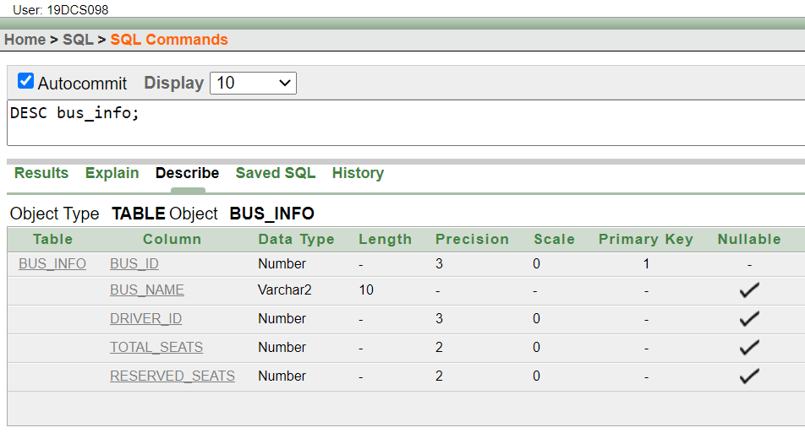

* **DETAILS OF DRIVER TABLE**:

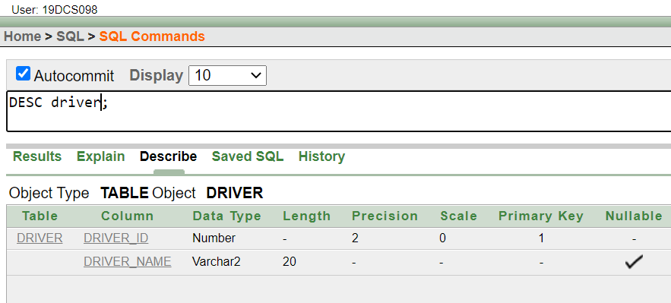

* **DETAILS OF CUSTOMER TABLE :**

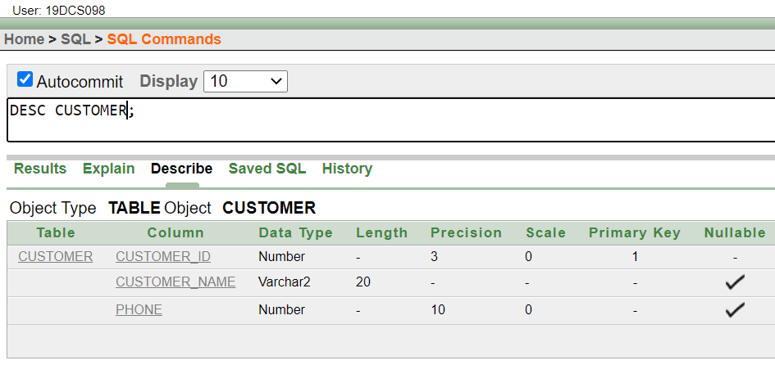

* **DETAILS OF RESERVATION_STATUS TABLE**:

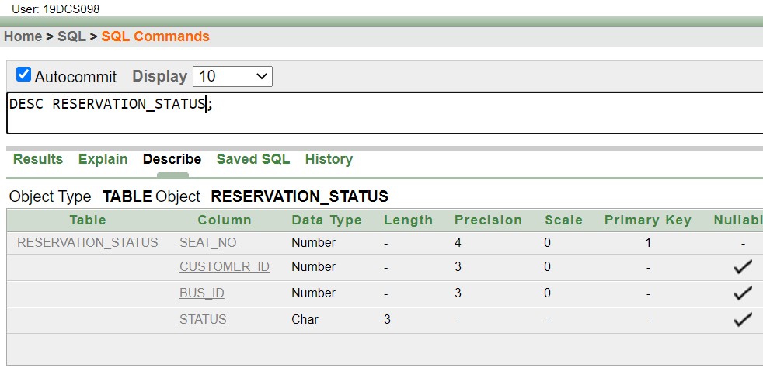

* **INSERTING DRIVER’S INFO USING PL/SQL PROCEDURE**:

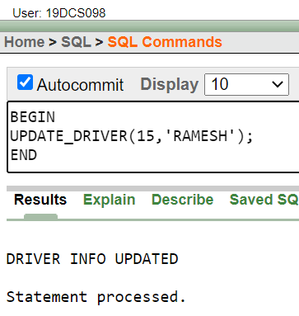

* **TABLE OF DRIVER AFTER UPPDATION:**

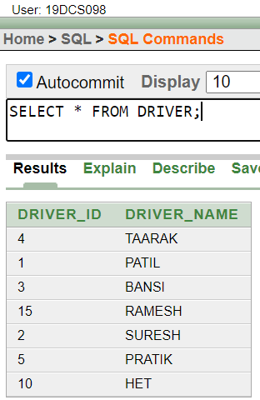

* **UPDATING BUS INFO USING PL/SQL PROCEDURE:**

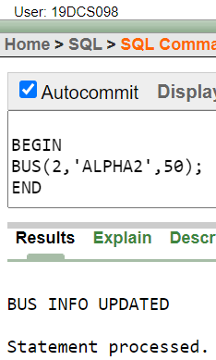

* **ASSIGN DRIVER TO HIS/HER BUS:**

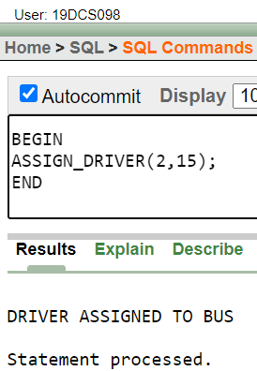

* **INSERTING DATA OF NEW CUSTOMER**

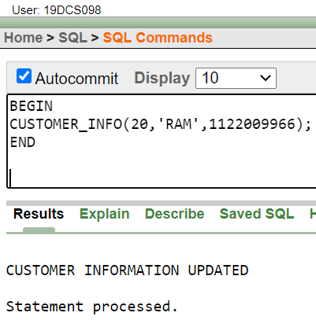

* **ASSIGNNING SEATS IN RESERVATION QUOTA**

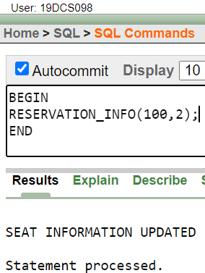

* **CONFIRMING THE RESERVATION**

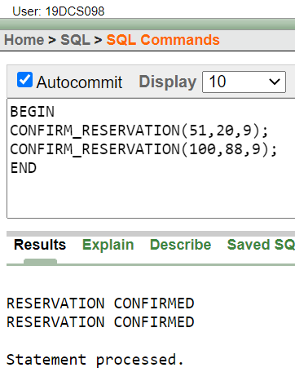

* **CANCEL THE RESERVATION**

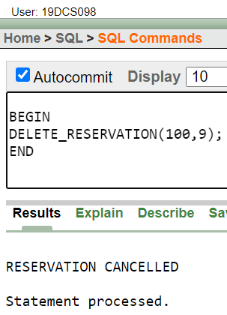

* **GLIMPSES OF ALL TABLES AFTER PERFORMING THE ABOVE OPERATIONS:**

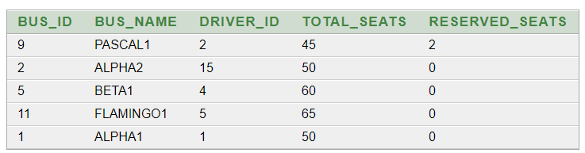

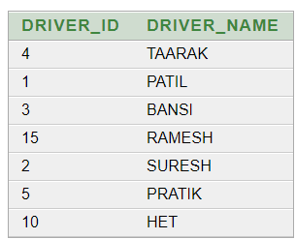

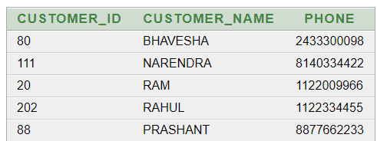

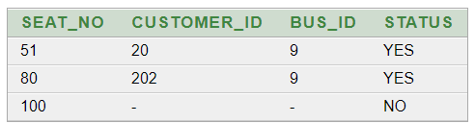

* **GLIMPSE OF VIEWS OF CUSTOMERS HAVING CONFIRMED SEATS**

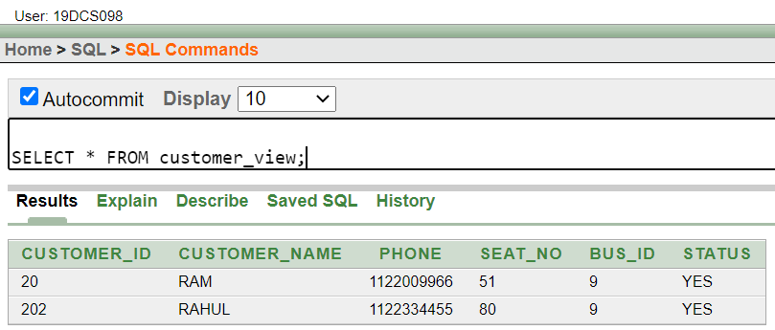

* **GLIMPSE OF VIEW OF ASSIGNED DRIVER**

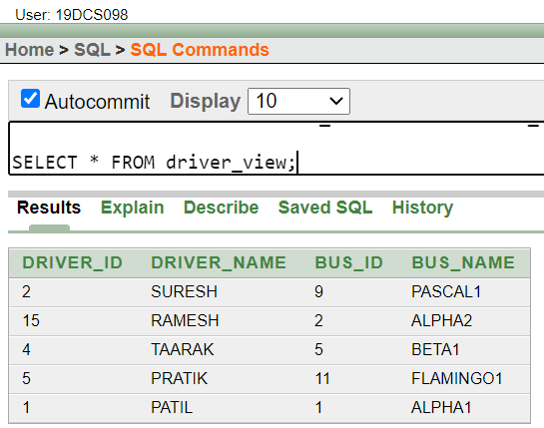

* **GLIMPSE OF OWNER**

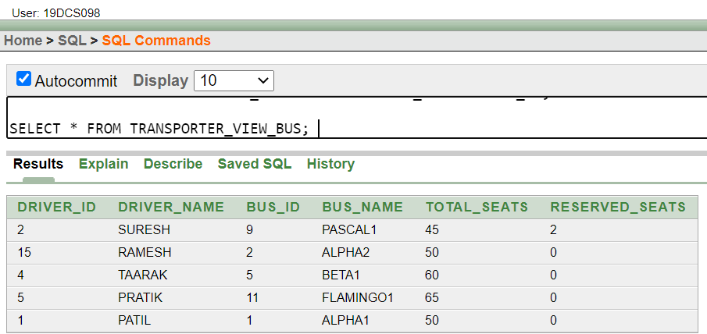

**CONCLUSION:**

By doing this mini project we polished our skills in DBMS,PL/SQL,SQL and other concepts